Batch: C2 Roll No.: 16010121200

Experiment / assignment / tutorial No. 2

Grade: AA / AB / BB / BC / CC / CD /DD

Signature of the Staff In-charge with date

Title: Implementation of different operations on Linked List – creation, insertion, deletion, traversal, searching an element

Objective: To understand the advantage of linked list over other structures like arrays in implementing the general linear list

Expected Outcome of Experiment:

CO | Outcome
CO 1 | To understand the advantage of linked list over other structures like arrays in implementing the general linear list

Books/ Journals/ Websites referred:
- Fundamentals Of Data Structures In C – Ellis Horowitz, Satraj Sahni, Susan Anderson-Fred
- An Introduction to data structures with applications – Jean Paul Tremblay,
- Paul G. Sorenson
- Data Structures A Pseudo Approach with C – Richard F. Gilberg & Behrouz A. Forouzan

Introduction:
A linear list is a list where each element has a unique successor. There are four common operations associated with linear list: insertion, deletion, retrieval, and traversal. Linear list can be divided into two categories: general list and restricted list. In general list the data can be inserted or deleted without any restriction whereas in restricted list there is restrictions for these operations. Linked list and arrays are commonly used to implement general linear list. A linked list is simply a chain of structures which contain a pointer to the next element. It is dynamic in nature. Items may be added to it or deleted from it at will.
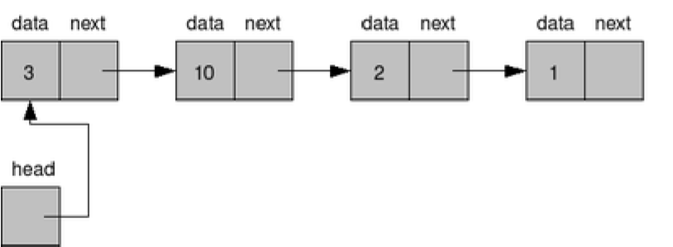
A list item has a pointer to the next element, or to NULL if the current element is the tail (end of the list). This pointer points to a structure of the same type as itself. This Structure that contains elements and pointers to the next structure is called a Node.
Related Theory: -
In computer science, a linked list is a linear collection of data elements, whose order is not given by their physical placement in memory. Instead, each element points to the next. It is a data structure consisting of a collection of nodes which together represent a sequence. In its most basic form, each node contains: data, and a reference to the next node in the sequence. This structure allows for efficient insertion or removal of elements from any position in the sequence during iteration.
Like arrays, Linked List is a linear data structure. Unlike arrays, linked list elements are not stored at contiguous location; the elements are linked using pointers
Linked List ADT:
The data is generally stored in key sequence in a list which has a head structure consisting of count, pointers and address of compare function needed to compare the data in the list.
Following operations can be performed:
get() – Return an element from the list at any given position.
insert() – Insert an element at any position of the list.
remove() – Remove the first occurrence of any element from a non-empty list.
removeAt() – Remove the element at a specified location from a non-empty list.
replace() – Replace an element at any position by another element.
size() – Return the number of elements in the list.
isEmpty() – Return true if the list is empty, otherwise return false.
isFull() – Return true if the list is full, otherwise return false.

Algorithm for creation, insertion, deletion, traversal and searching an element in assigned linked list type:
Creation:
    - Create a structure node having data and a pointer of type node.
    - Create a pointer Start and assign it the value NULL.
    - If Start is NULL, list is empty
    - Else insert new node at end of list.
Insertion:
i. Allocate memory for new node.
ii. Store data.
- Inserting at beginning:
    - Change next of new node to point at Start.
    - Change Start to point at recently created node.
- Inserting at end:
          - Traverse to last node
          - Change next of last node to point at recently created node.
          - Change next of new node to point at NULL.
- Inserting at middle:
                - Traverse to node just before required position of new node.
                - Store the next part of that node in a temporary variable.
                - Change next of that node to point at recently created node.
                - Change next of new node to point at value stored in the temporary variable.
Deletion:
- Delete from beginning:
- Change Start to point at second node.
- Delete from end:
- Traverse to second last element.
- Change next of that node to NULL.
- Delete from middle:
- Traverse to node just before node to be deleted.
- Change next pointer of that node to node after the node to be deleted.
Traversal:
- Assign Start to current pointer.
- Assign address of next node to current pointer to move to next node.
- Keep moving the current pointer to the next node.
- When next part of the current node is NULL, list ends.
Searching an element:
- Assign Start to current pointer.
- Run a loop until next part of current node is NULL.
- In each iteration, check if key of node is equal to the element.
Implementation of an application using linked lists:
Application: Representation and manipulation of polynomial
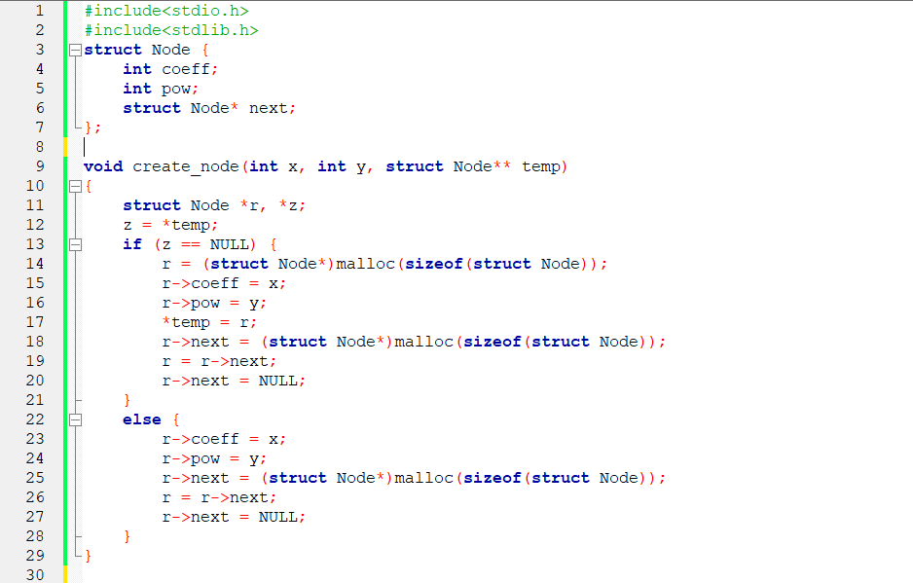
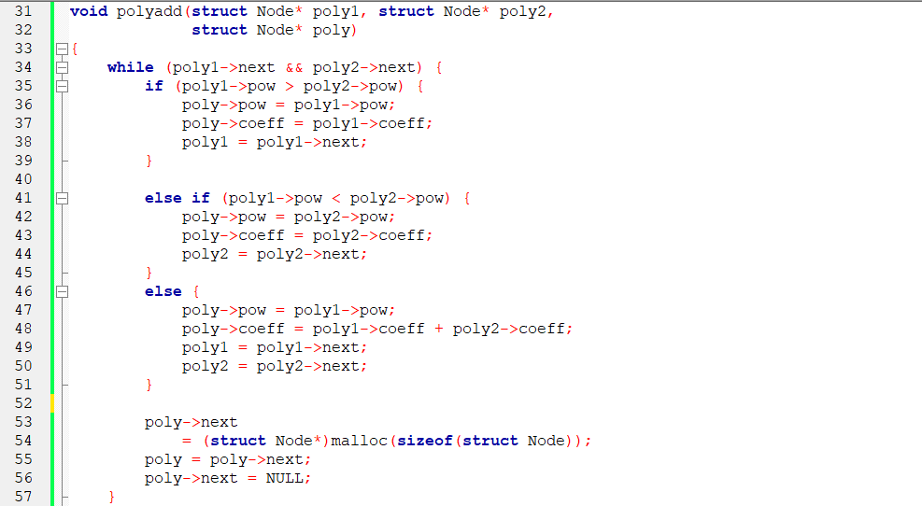
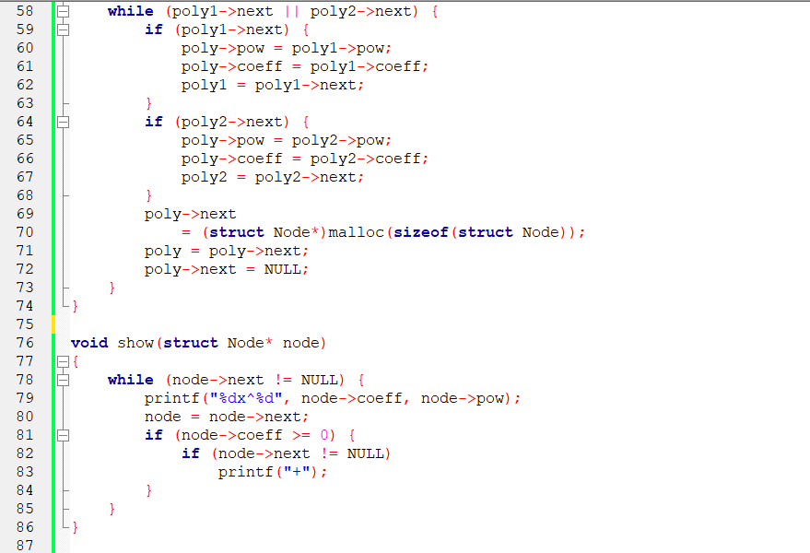
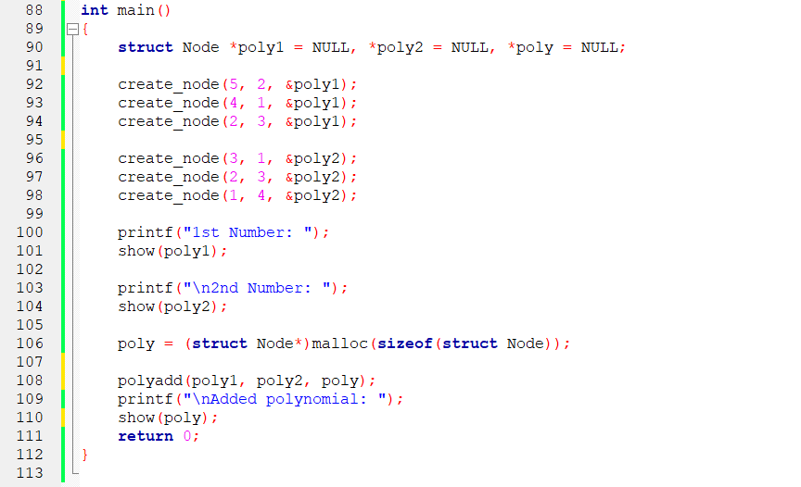

Output:
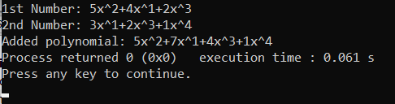

Conclusion:
Linked list is a linear data structure in which the elements are not needed to be stored at contiguous memory locations. The logical ordering is represented by having each node point to the next node. They are used when size of data is not known beforehand.
Post lab questions:
1. Write the differences between linked list and linear array
Linked list | Linear Array
Dynamic data structures – They grow and shrink during execution of program | Static data structure – Size of array is defined at time of programming
Efficient memory utilization – As memory is not pre-allocated. It can be allocated when required and de-allocated when not needed. Memory need not be contiguous. | Requires contiguous memory.  Memory once assigned cannot be changed which leads to wastage of memory if entire memory block is not utilized.
Insertion and deletion operations are easier and efficient. | Insertion and deletion operations are time consuming.
Access to arbitrary data item is cumbersome and time consuming. | Access to data item has constant access time as compiler maps a[i] to its physical location in memory.

2. Name some applications which uses linked list.
Some applications which use linked lists are:
- Implementation of stacks and queues.
- Maintaining a directory of names
- Performing arithmetic operations on long integers
- Representation and manipulation of polynomials
- Used in music players to keep a record of previous and next song track.

